http://accessories.us.dell.com/sna/productdetail.aspx?c=us&l=en&s=soho&cs=ussoho1&sku=320-9715&~ck=dellSearch&baynote_bnrank=0&baynote_irrank=4

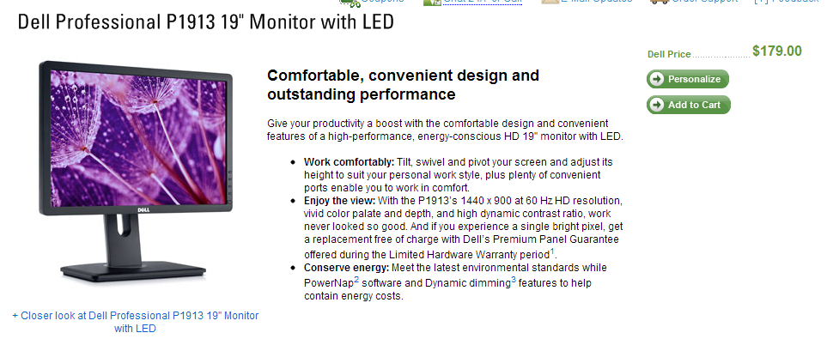

179.00 x 8

http://configure.us.dell.com/dellstore/config.aspx?oc=spctsbm1n&model_id=optiplex-3010&c=us&l=en&s=soho&cs=ussoho1

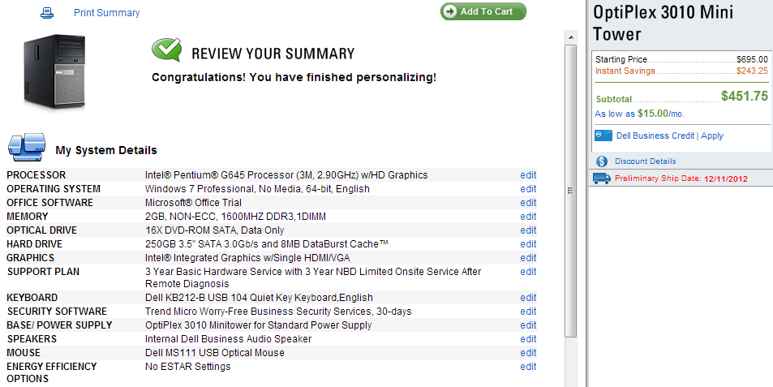

451.75 x 6

SERVER

http://www.tigerdirect.com/applications/SearchTools/item-details.asp?EdpNo=6613541&CatId=2670

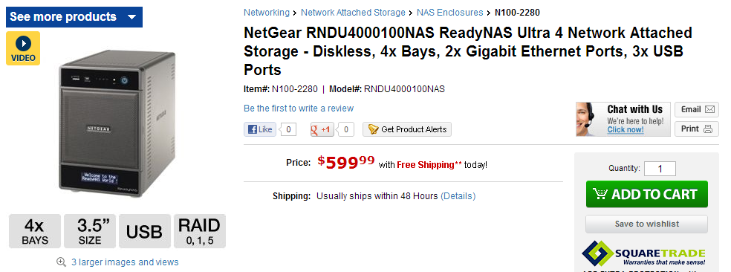

$599.99

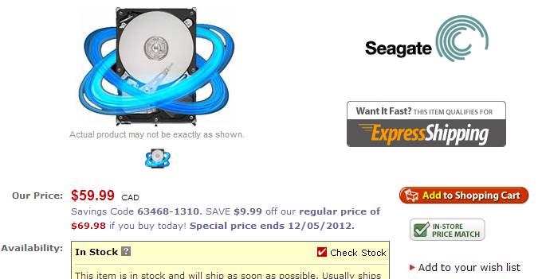

$69.98 x 3 = $209.94

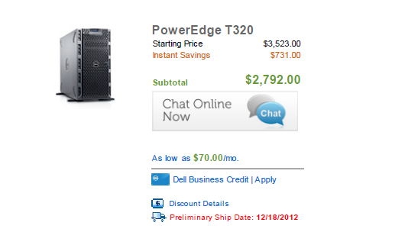

$3,523

$153.75 monitor keyboard mouse

<http://www.router-switch.com/Price-cisco-switches-cisco-switch-catalyst-3750_c21?productsort=1>

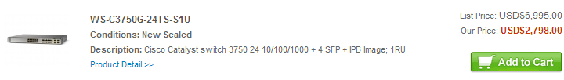

2798.00